Positions: Postdoctoral and Research Fellow

The School of Tourism Management (http://stm.sysu.edu.cn), located in the Zhuhai Campus of Sun Yat-sen University, is a well-known institution of tourism education and research. It is highly research-oriented, with more than 30 full faculty members continuously striving for academic excellence. According to the 2019 Shanghai Ranking's Global Ranking of Academic Subjects,,the major of Hospitality & Tourism Management at our school is ranked No.8 globally and No.1 among the universities in Mainland China.

Our school invites applications and nominations for full-time positions with background of Tourism Management, Hospitality and Hotel Management, Event Management, or related fields.

Qualifications & Compensations

- Postdoctoral Fellow (Two to three years program)
- Have an earned Ph.D. degree by time of appointment
- Have received doctoral degree no more than 3 years
- Demonstrate strong research capabilities
- Annual salary ranges from 190,000 - 290,000 RMB/year
- Other benefits include: university houses with low rents

- Research Fellow (Three years program)
- Have an earned Ph.D. degree by time of appointment
- Good publications record in the relevant field
- Working experience with universities or institutions is preferred
- Annual salary ranges from 190,000 - 240,000 RMB/year
- Other benefits include: university houses with low rents

Interested candidates should submit the followings to Mr Yang (HR affairs) at yangqi29@mail.sysu.edu.cn:
- Resume since college with a list of research projects, publications and awards in the past five years;
- Research proposal after joining SYSU

Note: Please kindly indicate your source in the email.

About STM at Sun Yat-sen University
Established in November 2004, School of Tourism Management was among the first batch of units that has the right of granting the Doctoral Degrees in Tourism Management and the MTA Degrees. It has received the United Nations World Tourism Organization (UNWTO) TedQual Certification, and has been serving as the Tourism Standardization Research Base of China Tourism Academy, the Management Unit for the Monitoring Center for UNWTO Sustainable Tourism Observatories, and the head of board of the Tourism Education Branch of China Tourism Association. The School has a complete the academic degree authorization system consists of undergraduate and postgraduate students, with a mobile post-doctoral station.

As one of a few Chinese schools that can claim international reputation and standing, STM provides students and faculty members with a platform for enhancing teaching, learning and research excellence. Driven by the mission of “providing world-class tourism and hospitality management education”, STM is now presented with new opportunities for growth and is gathering the leading talents from all over the world.

About Sun Yat-sen University
Sun Yat-sen University, founded by Dr. Sun Yat-sen and with an educational tradition spanning over 100 years, is a preeminent research, academic and cultural center and the premier location for talent development in South China.

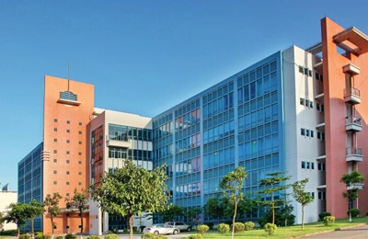 | 